READING COMPREHENSION TEXT # 3 5th YEAR
On April 10th, 1912, the Titanic – the largest ship afloat, left Southampton, England on
her maiden voyage to New York City.
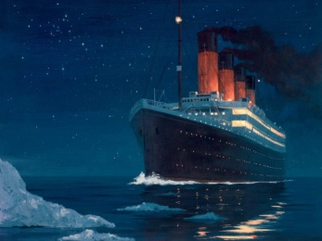
A legend even before she flooded , her passengers were a mixture of the world's wealthiest enjoying in the elegance of
first class accommodation and immigrants packed into steerage.
It was thought as the safest ship ever built, so safe that she carried only 20 lifeboats- enough to provide accommodation for
only half of her 2,200 passengers and crew.
Four days into her journey, at 11:40 P.M. on the night of April 14, she struck an iceberg. The collision was fatal and the
icy water soon poured through the ship.
It became obvious that many would not find safety in a lifeboat. Each passenger was issued a life jacket but life expectancy
would be short when exposed to water four degrees below freezing. As the forward portion of the ship sank deeper,
passengers scrambled to the stern.
The great ship slowly slid beneath the water two hours and forty minutes after the collision .
The next morning, the liner Carpathia rescued 705 survivors. One thousand five hundred twenty-two passengers and
crew were not found .
Subsequent inquiries attributed the high loss of life to an insufficient number of lifeboats and inadequate training in their use.
EXERCISE 1: TRUE or FALSE?
Titanic was a great ship.

The ship was created to be the unsinkable ship.

The Titanic completed its journey after the crash.

The passengers were just wealthy people from Europe.

The ship was prepared for anything that could ever happen.

The ship took almost three hours to sink into the ocean.

Around one thousand and five hundred passengers were rescued.

The Titanic had life jacket for every passenger.

All passengers could get in the lifeboats and wait to be rescued.

EXERCISE 2: Answer the questions below
- What would have happened if the Titanic had sailed to South Africa?
- What would have happened if the ship had had more life boats?
- What would have happened if it had been summer?
- What would have happened if there had been more liners close by?

