**In the thirteenth Century Scotland was under the despotic and tyrannical rule of Edward I, the English King better known as Edward the Longshank.**

**In a remote corner of Scotland lived William, orphaned son of Malcolm Wallace who had lost his life defending his people and his lands from English oppression. It was William’s wish to continue his father’s legacy; to fight for freedom of the Scottish people.**

**When William’s father died he was placed under the tutelage of his Uncle Argy ll. During**

**his childhood William received the best education; not only did he acquire military**

**knowledge but he also learned several languages as well as acquiring exceptional manners;**

**resigning, thus, his father’s legacy.**

**Upon completing his education, William decided to go home… and this is where our story**

**begins.**

**The reencounter with his childhood friends and his wish to have a family led to the fact**

**that, even though he wasn’t aware of it, he was in fact returning to his village with an entirely**

**different objective…. Even bigger than his own dream!**

**What is the dream that so motivates William?**

**Would it be possible for William to achieve his goal given that Scotland was under English rule?**

**What did his friends think of all this?**

**After centuries of living at the service of the English King, Scotland needed a change! But it wouldn’t be easy… conflict, banishment, a series of battles and two people living apart, united by love.**

**Join us in this wonderful adventure, full of passion, courage and love! And let’s all be**

**complicit with the wonderful dream of William Wallace… the Braveheart!**

**Read and complete the lyrics of the song. Use the words from the box.**

**Then listen and check**

**Freedom... Red and Black**

**moment Time game blood past light feel desire despair colour price world today night decide**

|  |  |
| --- | --- |
| **http://gb.fotolibra.com/images/previews/625322-united-kingdom-outline-map.jpegIt is 1- ____________ for us all To 2- ___________ who we are Do we fight for the right To a night at the opera now? Have you asked of yourselves What’s the 3- ________ you might pay? Is it simply a 4- ____________ For rich young boys to play? The 5- _________ of the world Is changing day by day  Red: the 6- _________ of angry men! Black: the dark of ages 7- __________! Red: a 8- ___________ about to dawn! Black: the 9- __________ that ends at last!** | **Have you seen her 10- ___________ You might know how it feels To be struck to the bone In a 11- ___________ of breathless delight! Have you been there today You might also have known How the world may be changed In just one burst of 12- ____________! And what was right seems wrong And what was wrong seems right!  Red: I 13- ___________ my soul on fire! Black: My world if she's not there! Red: The colour of 14- __________! Black: The colour of 15- ____________!** |

**Listen to the song “YOUR EYES” and complete with the correct form of the verbs in brackets**

***(From the musical “Rent”)***

**Your Eyes   
As We 1- (Say) __________ Our goodbyes   
Can't2-(get) __________ them out of my mind   
And I find I can't hide**

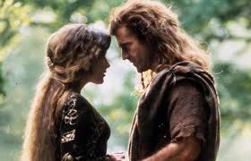**(From) your eyes   
The ones that 3-(take) __________ me by surprise   
The night you 4-(come) __________ into my life   
Where there's moonlight   
I see your eyes   
  
How'd I let you slip away   
When I 5- (long) __________ so to hold you   
Now I'd die for one more day   
'Cause there's something**

**I should 6- (tell) __________ you   
Yes there's something**

**I should 7- (tell) __________ you   
  
When I 8- (look) __________ into your eyes   
Why 9- ______ distance (make) ________ us wise?   
You 10- (be) __________ the song all along   
And before the song 11- (die) __________   
  
I should tell you, I should tell you   
I 12- (always/ love) __________ you   
You can see it in my eyes**

***Read the song “I WANT IT ALL” and translate the words in brackets into English. Then listen to the song and check.***

**I want it all, I want it all, I want it all, and I want it 1- (ahora) ___________!**

**I want it all, I want it all, I want it all, and I want it ! 2- (ahora) ___________!**

**I am 3- (rey) __________ Edward! on an empty 4- (calle) __________  
Just an alley creeper light on his feet  
young fighters screaming with no time for 5- (duda) __________  
With the 6- (pena) __________ and anger can't see a 7- (salida) __________  
It ain't much I'm asking, you have to pay!**

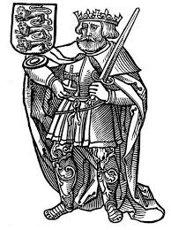**You just have to pay the 8- (impuestos) __________, move out of my way!!**

***I WANT IT ALL …*   
Listen all you 9- (gente) __________ come gather round  
I gotta get me a new game plan gotta shake you to the ground   
Just give me what I know is mine  
People do you hear me just give me the sign  
It ain't much I'm asking you just have to 10- (pagar) ___________  
You just have to pay the 11- (impuestos) __________,, get out of my way!**

***Listen to the song “I DON´T KNOW HOW TO LOVE HIM” and order the stanzas***

**Yet, if he said he loved me,  
I'd be lost, I'd be frightened.  
I couldn't cope, just couldn't cope.  
I'd turn my head, I'd back away,  
I wouldn't want to know,  
He scares me so…  
I want him so…  
I love him so. D**

**I never thought I'd come to this -  
What's it all about B**

**Don't you think it's rather funny  
I should be in this position?  
I'm the one who's always been  
So calm, so cool, no lover's fool  
Running every show  
He scares me so. C**

**Should I bring him down? Should I scream and shout?  
Should I speak of love - let my feelings out?  
I never thought I'd come to this -  
What's it all about? A**

**1- ______**

**2- ______**

**3- ______**

**4- ______**

**5- ______**

**6- ______**

**I don't know how to love him,  
What to do, how to move him.  
I've been changed, yes, really changed.  
In these past few days when I've seen myself,  
I seem like someone else. F**

**I don't know how to take this  
I don't see why he moves me.  
He's a man, he's just a man.  
And I've had so many friends before  
In very many ways  
He's just one more. E**

**Make up sentences out of the words given. Then listen to the song**

***“IT'S A BEAUTIFUL DAY”* and check**

**It's a beautiful day,  
shining / sun / is / the _____________________________________________  
feel / good / I____________________________________________________  
Yeah / no / and / ´s / stop / now / me / gonna / one / oh**

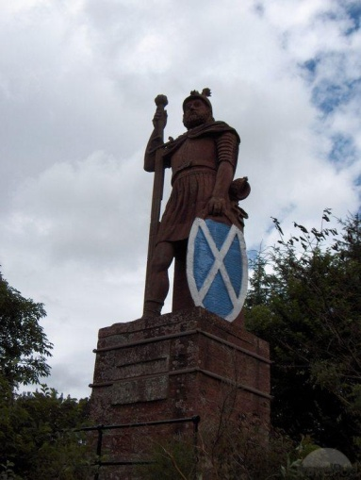**___________________________________________  
  
It's a beautiful day,  
I/ good/ right / feel / I / feel, _________________________  
Yeah / no / and / ´s / stop / now / me / gonna / one / oh**

**___________________________________________  
Mama.**

**Sad / so / so / sad / sometimes / feel / I / sad / so /  
gonna / me /now / one / no / but / ‘s / stop**

***So / will / I / try / this / place / Scotland / my / in / is***

***Listen to the song “BIJOU” and circle the correct word***

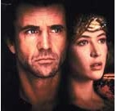**You and *1- (my /me)* we *2- (were /are*) destined *3- (you / we)* 'll agree  
To *4- (send / spend)* the rest of *5- (their /our)* lives with each other  
The rest of *6- (their /our)* days like *7- (to / two)* lovers,  
*8- (four / for)* ever,Yeah,  
*9- (four / for)* ever, 10- *(I / My*) bijou.**

***Listen to the song “BIJOU” and circle the correct word***