Best Known For
Albert Einstein was a German-born physicist who developed the theory of relativity. He is considered the most influential physicist of the 20th century.
READING COMPREHENSION TEXT# 2 6th YEAR
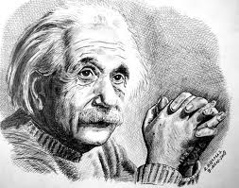

Quick Facts
- NAME: Albert Einstein
- OCCUPATION: Physicist
- BIRTH DATE: March 14, 1879
- DEATH DATE: April 18, 1955
- EDUCATION: Luitpold
- Gymnasium, Eidgenössische Polytechnische Schule (Swiss Federal Polytechnic School)
- PLACE OF BIRTH: Ulm, Württemberg, Germany
- PLACE OF DEATH: Princeton, New Jersey
Albert Einstein was born in 1879 in the German city of Ulm. He had been no infant prodigy; indeed, he was so late in learning to speak that his parents feared he was fool. In school, though his teachers saw no special talent in him, the signs were already there. He taught himself calculus, for example, and he said that his teachers seemed a little afraid of him because he asked questions they could not answer. At the age of 16, he asked himself whether a light wave would seem stationary if one ran side by side of it. It seems an innocent question, but this shows Einstein going to the heart of a problem. From it there would arise, ten years later, his theory of relativity.
I) Choose the best alternative

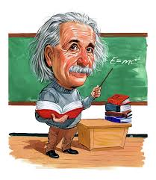
1. Albert Einstein ----.
A) is the most genius scientist of all
B) was born in the 18th century
C) was spoiled by his teachers in school
D) made his parents afraid due to his problem in speech in his childhood
E) seemed to have special ability
2. When he was in school, Einstein ----.
A) showed no signals about his genius
B) was afraid of his teachers due to their innocent questions
C) asked difficult questions to his teachers
D) was understood as genius by public when he was a teenager
E) couldn't teach himself even one science

3. It's obvious in the passage, Einstein's ----.
A) genius was a gift
B) character was perfect to most of his teachers
C) life encouraged most of the scientist in the world
D) theory of relativity couldn't be proved by himself
E) question is the origin of his theory of relativity

